ERP and Process Transformation
H1: ERP and Process Transformation Services That Move Your Business from Manual Effort to SOP-Driven, AI-Ready Operations
Sub-heading (lead paragraph): Process transformation helps unlock a more productive way of working. Contetra’s ERP and process transformation services helps growing and established businesses move away from spreadsheet-led, people-dependent operations and towards a documented, controlled and system-supported way of working. We combine ERP functional consulting, process design and AI-enabled automation so that your operations become faster, more reliable and ready to scale without proportionately increasing headcount.
Supporting paragraph: We work as an independent, platform-agnostic partner across SAP, Microsoft Dynamics, Oracle, NetSuite, Odoo, ERPNext and other enterprise systems. Our role is to protect the business outcome, not to sell a licence or a customisation. That means we start with how your business should operate, translate it into clear standard operating procedures and system requirements, and then govern the change through to adoption.
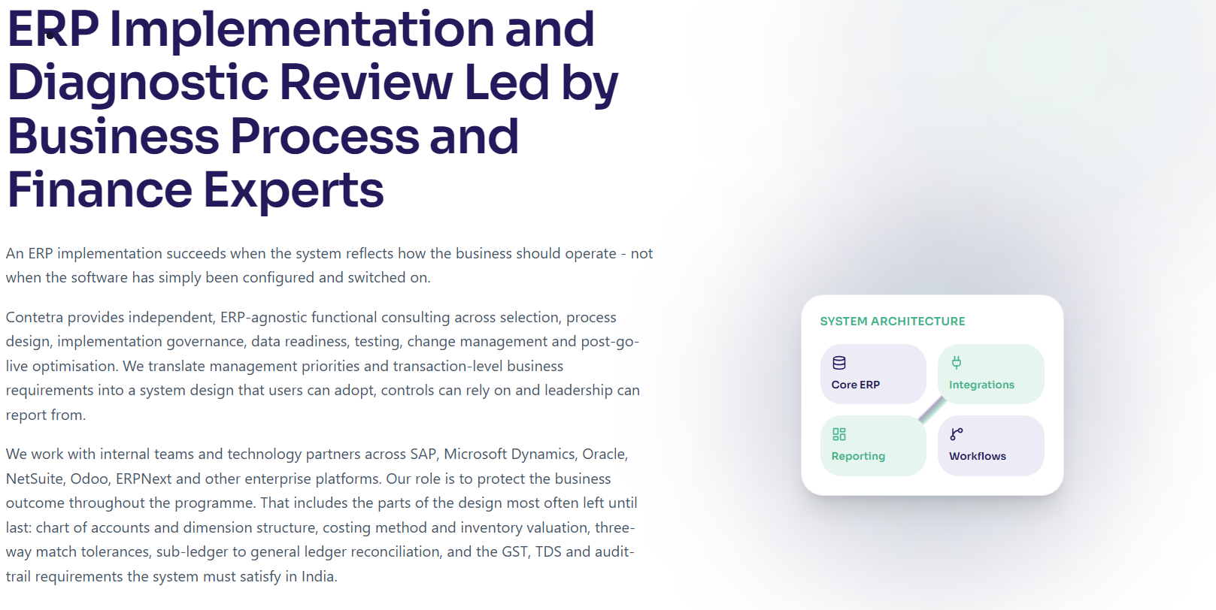

Kicker line above buttons: Get in touch with us to transform your processes from manual operations to SOP-driven Process Transformation, and open up a wide horizon of AI use across your workflows.
Primary button: Request an ERP Diagnostic Review Links to: /contact-us
Secondary button: Book an ERP Program Consultation Links to: /contact-us
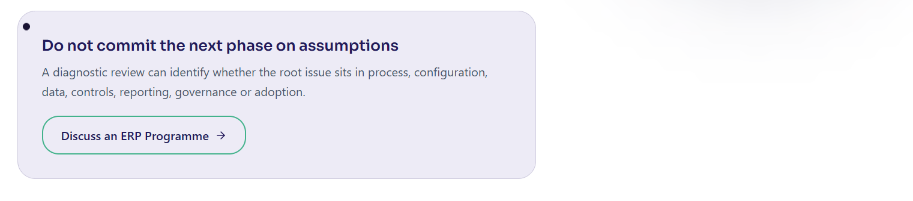

2. Customers we work with (client logos)
Section label: Trusted by finance and business leaders
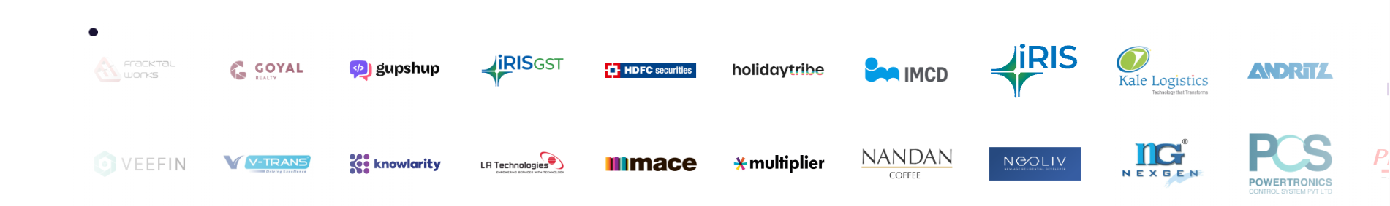

3. What challenges are being faced (target audience pain points)
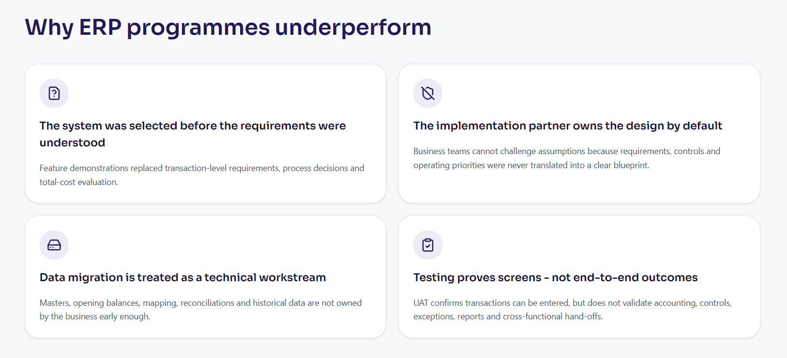
Section heading: Operational challenges ERP and Process Transformation service help businesses solve (H2)
Intro line: Most businesses do not ask for "process transformation" by name. They come to us with the day-to-day symptoms of manual, disconnected operations. If any of these sound familiar, this is where we help.
Card 1 — Work still runs on spreadsheets and email Critical processes live outside the core system. Data is re-keyed between tools, versions conflict, and no single source of truth exists for management to rely on.
Card 2 — The ERP is live, but the business works around it Users bypass the system, reports do not reconcile, and the software reflects vendor defaults rather than how the business actually operates.
Card 3 — Every process depends on specific people Approvals, reconciliations, follow-ups and reporting depend on individual knowledge. When a key person is away, the process stalls.
Card 4 — Manual effort grows faster than the team Recurring tasks such as data entry, matching, status updates and reconciliations consume hours that should be spent on analysis and decisions.
Card 5 — There are no documented SOPs Processes are undocumented or out of date, so training is slow, quality is inconsistent, and controls cannot be enforced or audited.
Card 6 — The business is not ready for AI or automation Leaders want to use AI in their operations, but the underlying processes are too unstructured, uncontrolled or undocumented for automation to be applied safely.

4. What solutions does Contetra offer
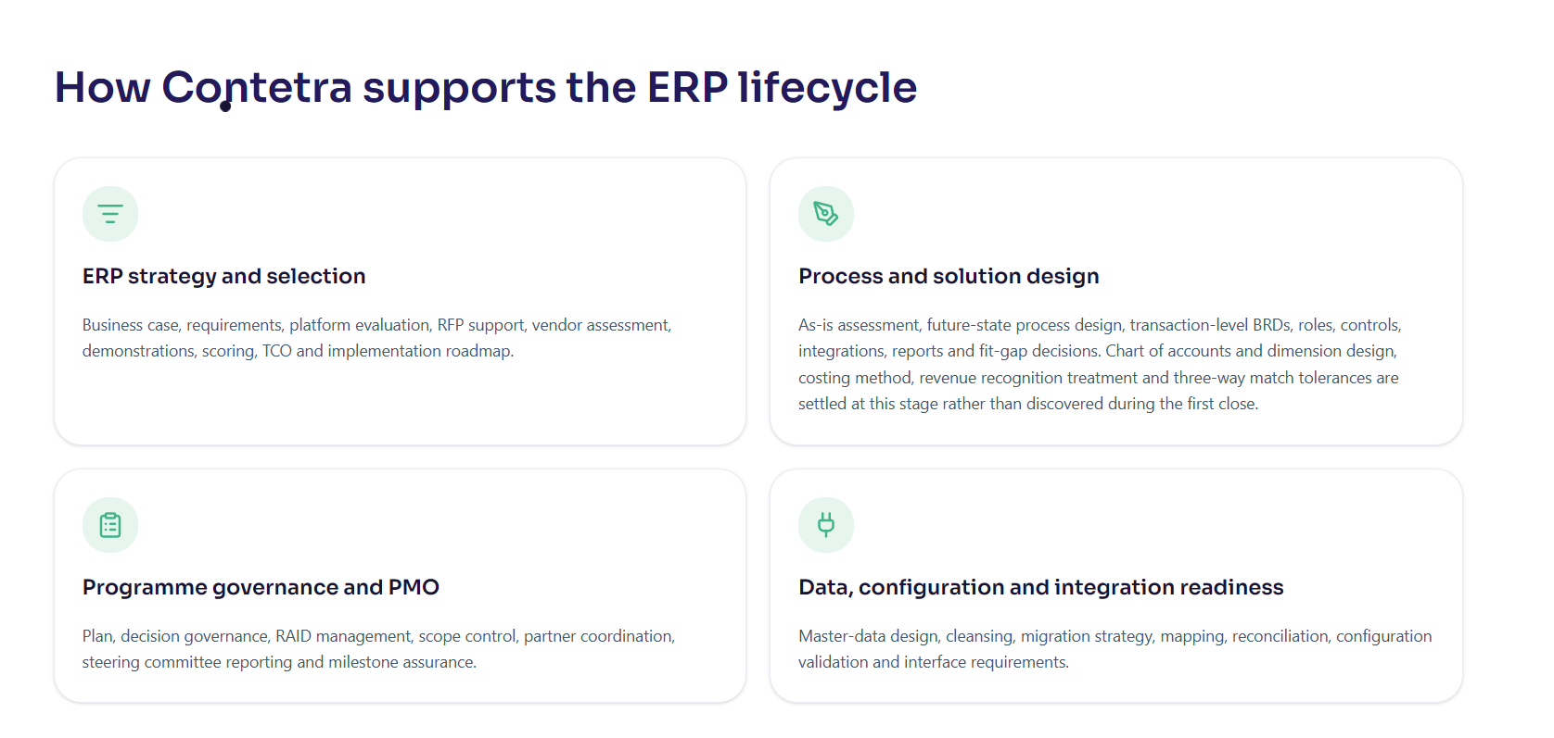
Section heading: How Contetra delivers ERP and Process Transformation (H3)
Intro line: We connect three capabilities that are usually treated as separate projects: ERP functional consulting, process and SOP design, and governed automation. Bringing them together is what turns a system implementation into a genuine ERP business process transformation.
Solution 1 — ERP strategy, selection and implementation Business case, transaction-level requirements, platform evaluation, RFP support, implementation governance, data readiness, testing and go-live. We make sure the system reflects how the business should run.
Solution 2 — Process design and SOP documentation As-is assessment, future-state process design, standard operating procedures, roles, controls and hand-offs. We turn tribal knowledge into documented, repeatable and auditable processes.
Solution 3 — ERP diagnostic review and health check An independent review of process, configuration, data, controls, reporting, governance and adoption, with a prioritised roadmap that tells you whether to stabilise, optimise, rescue or replace.
Solution 4 — ERP project rescue and post-go-live optimisation For stalled, delayed or underperforming programmes: root-cause analysis, a realistic recovery plan, remediation governance and post-go-live stabilisation.
Solution 5 — Implementation PMO and functional consulting Independent programme governance, requirement traceability, partner coordination, end-to-end testing, change management and business sign-off, so the outcome stays owned by your business.
Solution 6 — Process automation and AI enablement Once processes are documented and controlled, we automate the high-effort, repeatable steps and introduce governed AI agents with human approval controls, so your team focuses on judgement, not manual work.

5. Our existing offered solutions (case studies) (H3)
Case study slider
Section heading: ERP and process transformation work we have delivered
Intro line: A selection of engagements from our Digital Transformation practice. Explore the full set on our case studies page.
CFO Bridge Services (Professional Services) (h4) Before: the business had no ERP foundation, with finance and operations running on disconnected spreadsheets and tools. Solution: Contetra led a full ERP implementation covering requirements, BRD, CRP sessions, UAT and go-live. After: the business now runs on a unified platform with real-time financial visibility.
Andritz Technologies (Technology) (h4) Before: finance processes were undocumented, with no blueprint to configure or optimise the ERP. Solution: Contetra ran process workshops, documented current-state workflows and designed an ERP-aligned future state. After: process documentation was delivered and ERP configuration was grounded in real workflows, not generic templates.
Aditi Tracking Support (Manufacturing) (h4) Before: the ERP project had stalled, with an incomplete BRD and a repeatedly deferred go-live. Solution: Contetra took ownership of BRD finalisation, ran UAT sessions and drove the project to go-live. After: go-live was achieved, with documented processes and user-accepted workflows in place.
B M Fashions UK (Apparel and Textile) (h4) Before: user acceptance testing was incomplete and go-live readiness was unclear. Solution: Contetra structured the UAT cycle, tracked defect resolution and managed go-live sign-off. After: UAT was completed and go-live achieved, with business users confident in the system.
Abilities India Pistons and Rings (Auto and Engineering) (h4) Before: the finance team needed functional expertise to configure the ERP for their business model. Solution: Contetra provided hands-on ERP advisory across configuration review, workflow design and module optimisation. After: the configuration was optimised so the system reflects how the business actually operates.
Cogitate Technology Solutions (Technology) (h4) Before: the finance team lacked structured workflows in the ERP and usage was inconsistent across the organisation. Solution: Contetra completed BRD sign-off, ran structured UAT and oversaw go-live milestone delivery. After: ERP usage was standardised post go-live, with consistent workflows and documented processes embedded.
Club Sulaimani Food and Beverages (Food and Beverages) (h4) Before: the ERP was live but the finance team lacked confidence in its outputs and reporting accuracy. Solution: Contetra reviewed the configuration, corrected mapping errors and aligned reports to management needs. After: the finance team now relies on ERP output with confidence, with configuration corrected and reports validated.
Beautex Industries (Manufacturing) (h4) Before: the business had chosen an ERP platform but lacked internal expertise to implement it effectively. Solution: Contetra provided functional advisory across all finance modules, including AP, AR, GL and reporting. After: the ERP was implemented with proper finance controls embedded, and the team was trained on a sound system.
Section CTA link: Browse all case studies → /proof/case-studies

6. Insights and blogs (Process Automation)
Section heading: Insights on process automation and transformation
Intro line: Practical thinking on moving from manual operations to automated, AI-supported processes.
Developer note: pull the latest posts from /blog filtered to the Process Automation category, newest first, showing three to four cards. Do not hard-code titles, since the blog updates. Each card should show the post title, a short excerpt, the category tag and a "Read more" link to the post. Link the section heading to the blog filtered by Process Automation.
Section CTA link: Read more insights → /blog

7. Frequently Asked Questions (minimum 10)
Section heading: Frequently Asked Questions
Q1. What is ERP and process transformation? It is the work of redesigning how a business operates and then supporting those processes with the right system and automation. It combines ERP functional consulting, process and SOP design, and governed automation, so operations become documented, controlled and efficient rather than manual and people-dependent.
Q2. How is process transformation different from just implementing an ERP? An ERP implementation configures software. Process transformation first defines how the business should operate, documents it as standard operating procedures, and then uses the ERP and automation to support it. Without the process work, an ERP often just digitises existing inefficiencies.
Q3. We already have an ERP. Do we still need this? Often, yes. Many businesses have a live ERP that the team still works around, with processes on spreadsheets, reports that do not reconcile and low user confidence. An ERP diagnostic review identifies whether the issue is process, configuration, data, controls, reporting, governance or adoption, and what to fix first.
Q4. What does an ERP diagnostic review include? It examines your process and system usage, configuration and data, controls and reporting, and governance and adoption together. You receive a prioritised roadmap that separates quick stabilisation from process and control corrections, configuration improvements, data work and longer-term platform decisions.
Q5. Can you rescue an ERP project that has stalled or gone over budget? Yes. Our project rescue work reviews scope, governance, requirements, data, design, testing and partner performance, then sets out a realistic recovery plan with clear decisions, ownership and milestones before more time or cost is committed.
Q6. Which ERP platforms do you work with? We are platform-agnostic and can advise across SAP S/4HANA and Business One, Microsoft Dynamics 365, Oracle Fusion Cloud and E-Business Suite, Oracle NetSuite, Odoo and ERPNext or Frappe, and other mid-market and industry platforms. We also work with connected systems such as CRM, HRMS, WMS, banking, tax, reporting and workflow tools.
Q7. Why do standard operating procedures matter for automation and AI? Automation and AI can only be applied safely to processes that are documented, consistent and controlled. SOPs define the steps, rules, roles and exceptions, which becomes the foundation for both workflow automation and governed AI agents. Without SOPs, automation tends to speed up an unreliable process.
Q8. How does AI fit into process transformation? Once processes are documented and controlled, we introduce automation for the repeatable, high-effort steps and add governed AI agents for tasks such as data gathering, matching, drafting, monitoring and routing. Human approval controls remain in place for material actions, so you gain speed without losing control.
Q9. Are you an implementation partner or an independent consultant? We are an independent functional and process partner. An implementation partner configures and deploys the platform. We help you define requirements, govern the design, challenge trade-offs and protect the business outcome. We collaborate with your implementation partner rather than replace them.
Q10. What is the best way to start? For a broad or unclear situation, start with an ERP diagnostic review. It creates an independent fact base, identifies quick wins and defines a prioritised roadmap before you commit to a larger programme. Where the need is clearer, an ERP program consultation is the right first step.
Q11. How long does an ERP and process transformation engagement take? It depends on scope, business complexity, data quality and the availability of internal owners. A diagnostic review is a short, focused engagement, while a full implementation or automation programme runs over a longer period with defined phases. We scope the timeline with you after the initial review.
Q12. Do you support businesses outside Mumbai and India? Yes. We are based in Mumbai and work with promoter-led, growth-stage, multi-entity and global businesses. Our process and system work applies across locations, and we also address India-specific requirements such as GST, TDS and audit-trail rules where relevant.

8. Contact us (adapted, meaning preserved)
Section heading: Process transformation helps unlock a more productive way of working
Body: Get in touch with us to transform your processes from manual operations to SOP-driven Process Transformation, and to enable a wide horizon of AI use across your workflows. Tell us where things stand today, from stalled implementations and workarounds to manual reporting and reconciliation, and we will help you define the right starting point.
Contact details (reuse from the existing Contact page): Phone: +91 98338 18857 Email: growth@contetra.com Address: Contetra Private Ltd, 225, 2nd floor, Swastik Disa Corporate Park, LBS Road, Opposite Rajhans Cinemas, Ghatkopar-west, Mumbai 400086
Primary button: Request an ERP Diagnostic Review → /contact-us Secondary button: Book an ERP Program Consultation → /contact-us
Note on the two buttons: both currently point to /contact-us, matching how the live ERP pages route their CTAs. If you later build a dedicated diagnostic enquiry form, point the primary button there and keep the secondary button on the general contact route, so the two intents can be tracked separately.

9. Footer

